Git and GitHub- 02

- Git Flow branch names:
main
develop
feature/*
release/*
hotfix/*
- Easy to remember:
main → production
develop → development
feature → new work
release → ready to release
hotfix → urgent fix

- git branch --list is used to see/list all the branches in your local Git repository.

- To create a branch named release, use:

git branch release
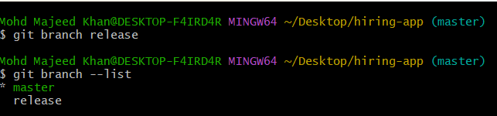
* Means you are currently on master.

- git checkout release command is used to switch from your current branch to the release branch.

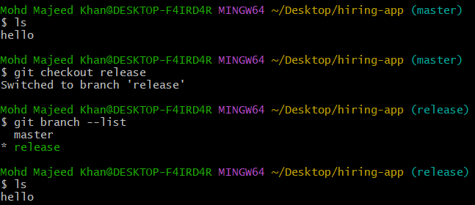
Create branch by using git branch hotfix - git checkout hotfix- ls

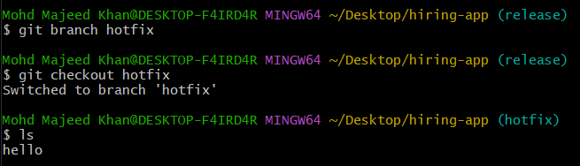

- git merge is used to combine the changes from one branch into another branch.
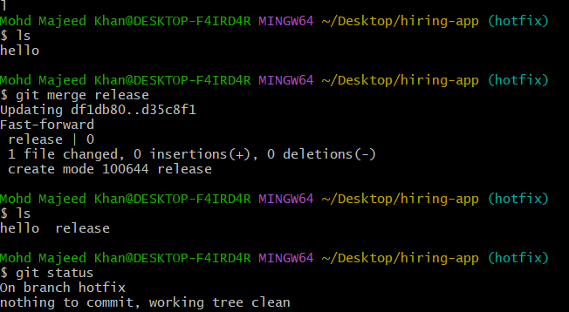
- Git cherry-pick command means taking one specific commit from another branch and applying it to the current branch by using the commit ID.
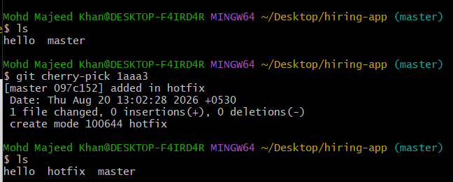
Pull Request (PR) is a request to merge changes from one branch into another branch on GitHub

- GitHub Pull Request Successfully Merged
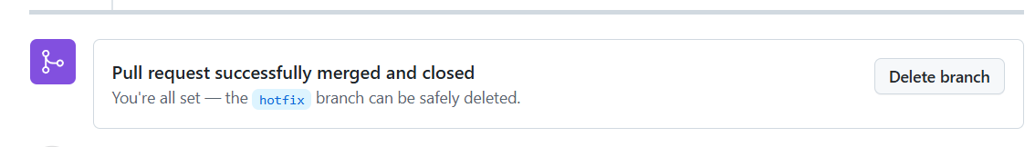

What does git commit --amend do?
It modifies/replaces your most recent commit instead of creating a new commit.
- 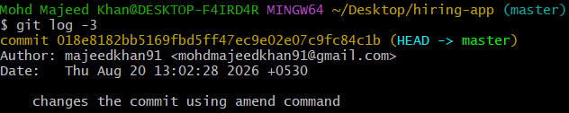

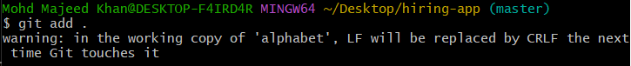
- git stash is used to temporarily save your uncommitted changes without committing them
- 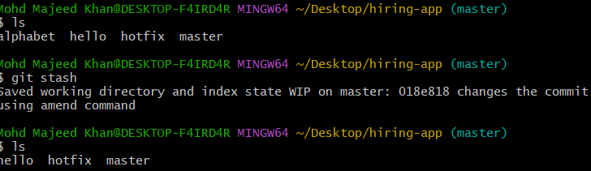
- git stash list: Shows all the changes that you have previously saved using git stash.

git stash pop Restores the latest stashed changes back into your working directory.

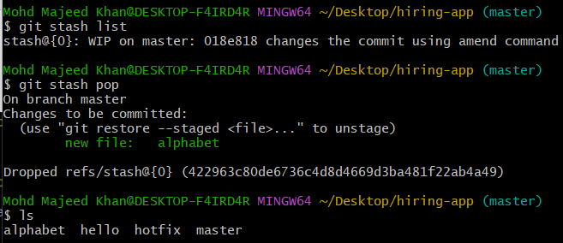
Git Merge Conflict
A merge conflict happens when Git tries to merge two branches, but both branches have changed the same part of the same file and Git cannot decide which change to keep.
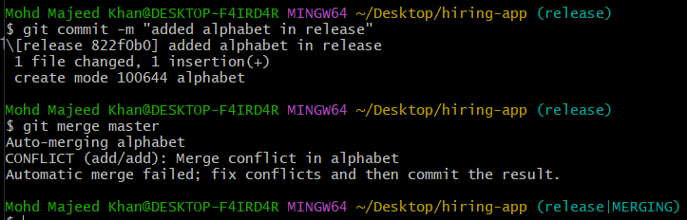

- Error: 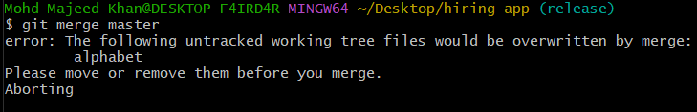
- 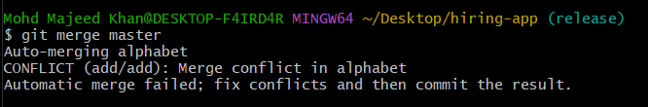
- 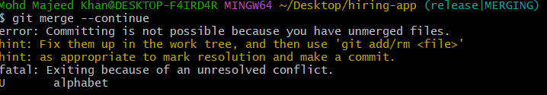

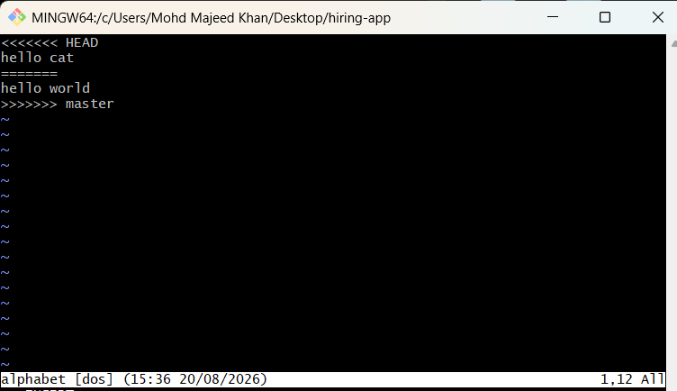
git merge --abort is used to cancel an ongoing merge conflict and return your working directory to the state it was in before the merge started.
- Git add . to merge
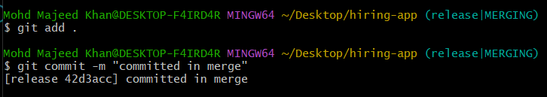

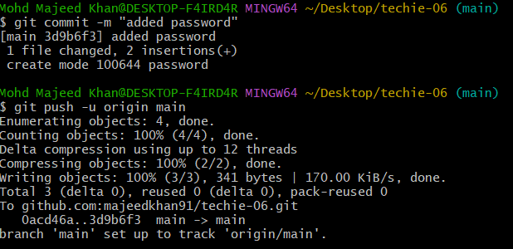
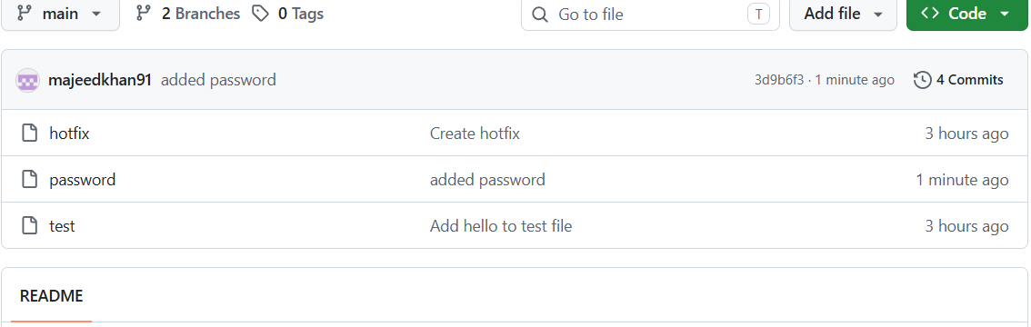
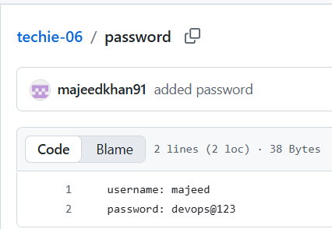

.gitignore is used to tell Git which files or folders should NOT be tracked or committed to the repository.
.gitignore = “Git, ignore these files.”
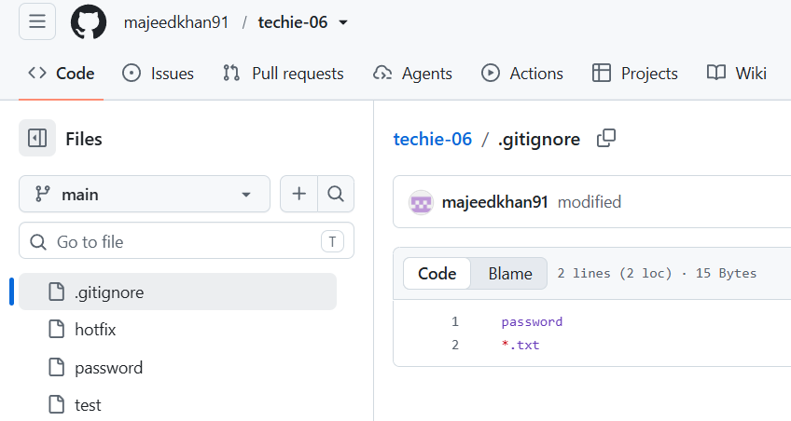
- git fetch = Download the latest information from the remote repository without merging it into your current branch.
- git rebase -i HEAD~4 — Interactively rewrite/edit the last 4 commits in your current branch.

Git and GitHub -02 / 22 Tasks-Completed

1: Install git
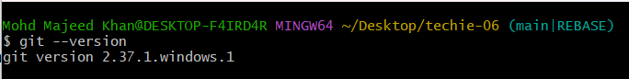

2: Create a repo in github with README.md and .ignore file.
gitignore is used to tell Git which files or folders should NOT be tracked or committed to the repository.
.gitignore = “Git, ignore these files.”
creating a new file github with README.md
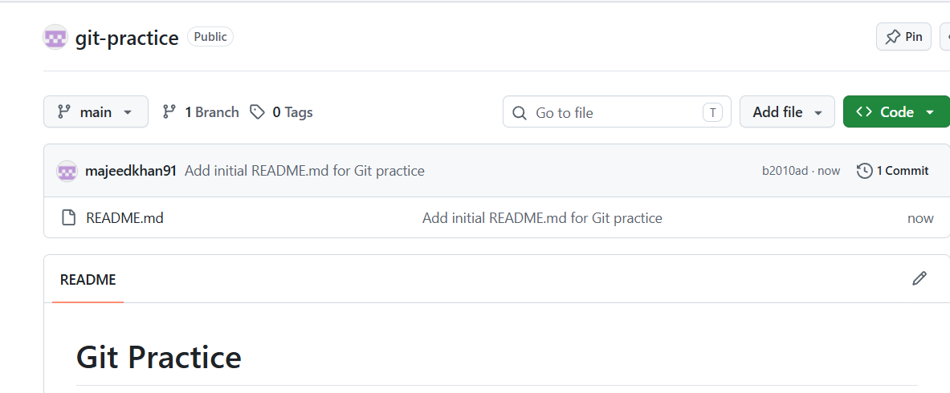

3: Clone the created repo to local: git clone creates a local copy of a remote Git repository, including its files, branches, commits, and Git configuration.
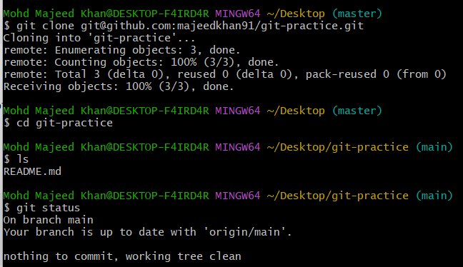

4: Create two files in local repo: touch is a Linux/Git Bash command used to create an empty file.
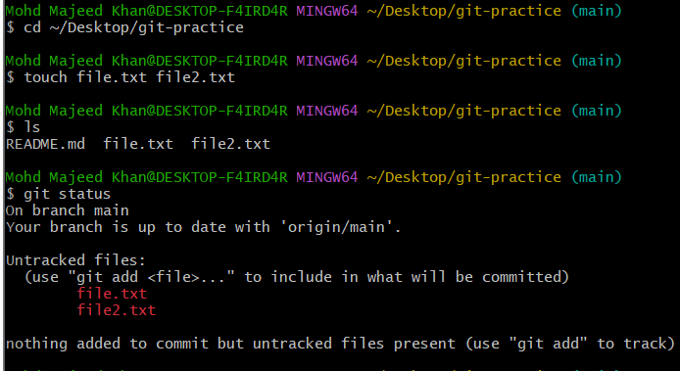

5: Commit two files and push to central Repository.
- git push origin main
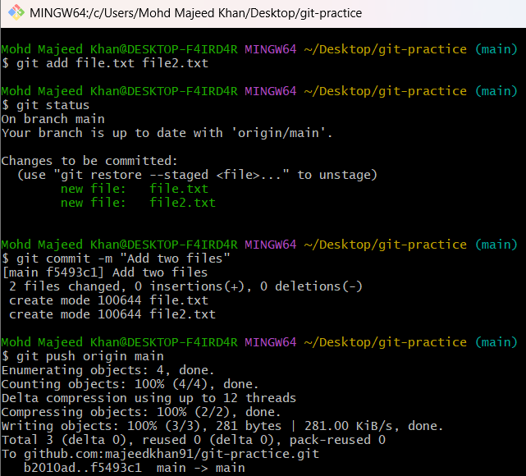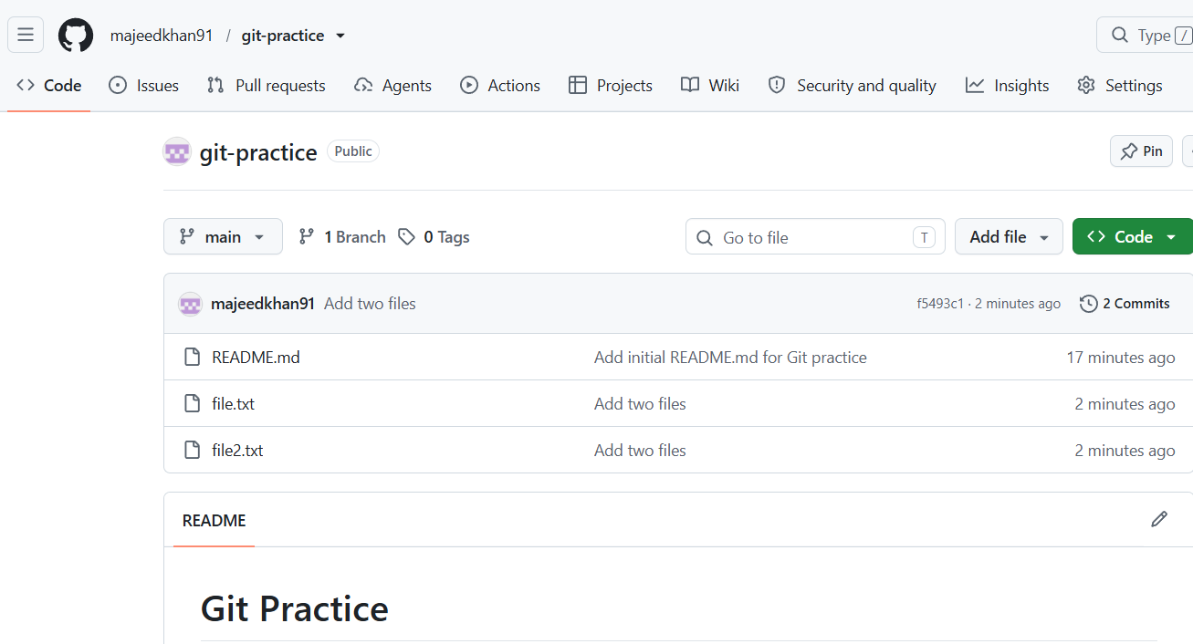

6: Create a branch in local and create a sample file and push to central:
git branch feature
git branch feature * main
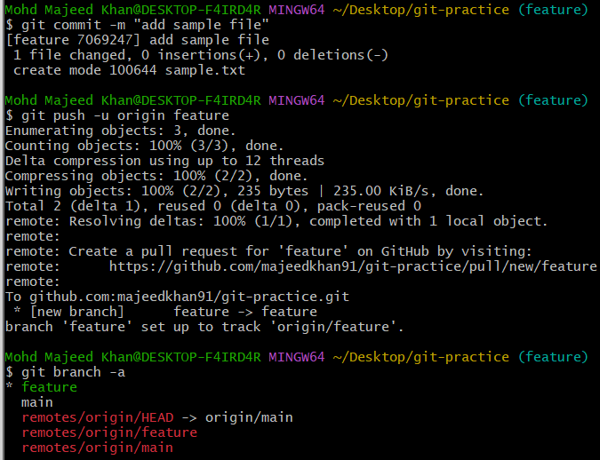
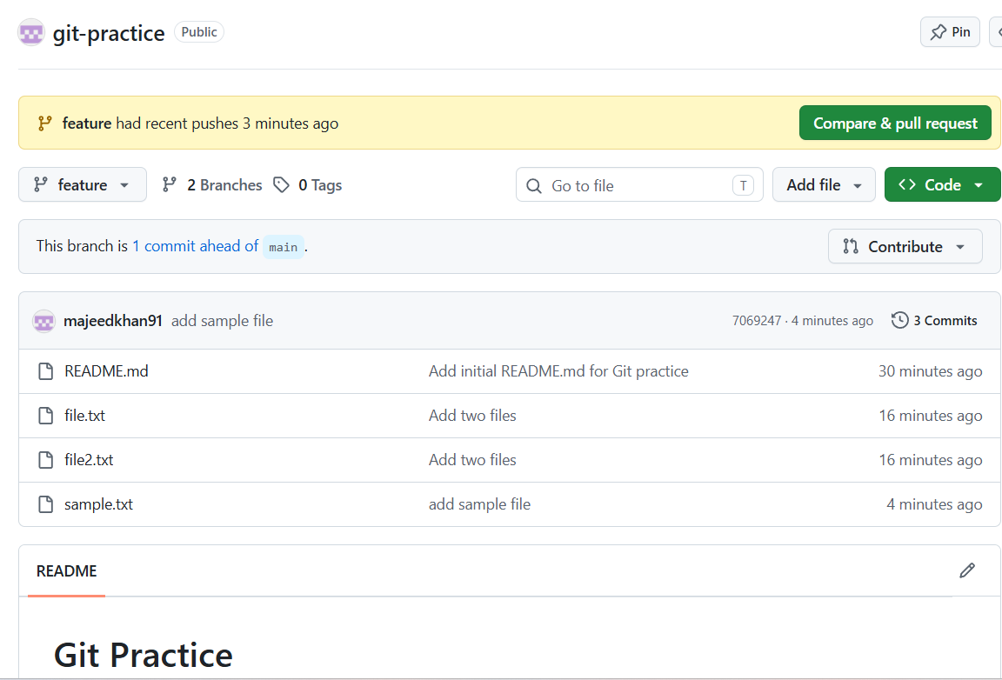
7: Create a branch in github and clone that to local.
Step 1: Create a branch on GitHub
Step 2: Clone that branch to local
clone the GitHub-created branch into a new local folder:
Step 3: Enter the new folder
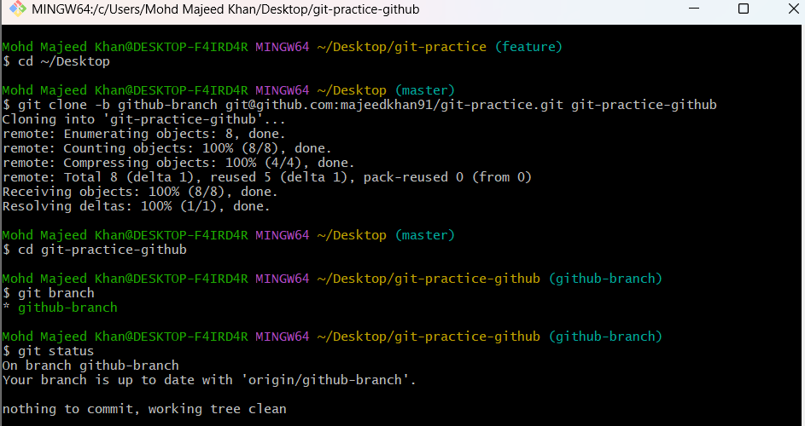
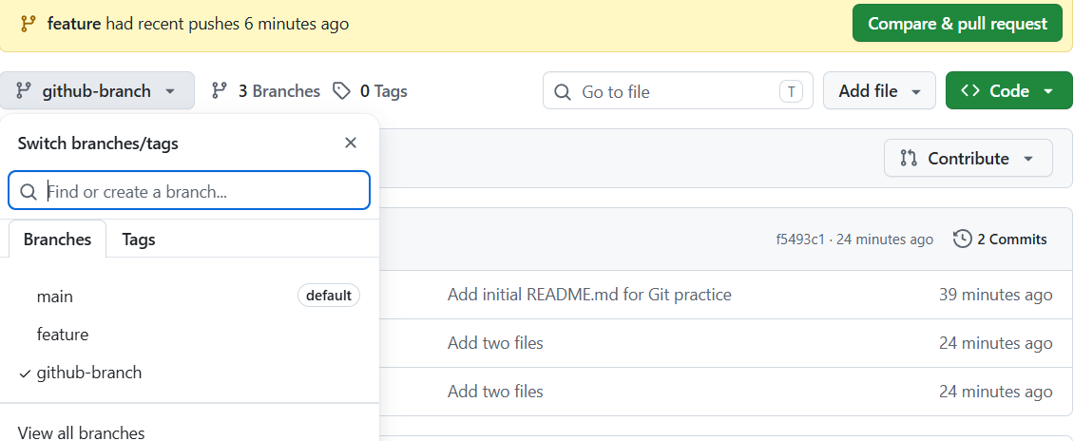

8: Merge the created branch with master in git local.
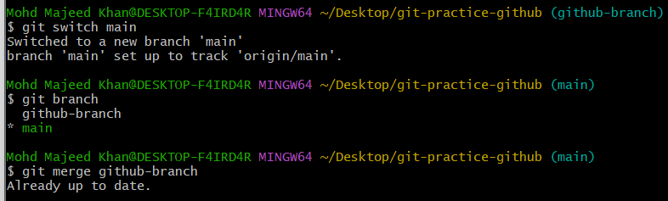

9:Merge the created branch with master in github by sending a pull request.
- Create and switch to a new branch:
git checkout -b feature
- Make the required changes in the feature branch.
- Check the status:
git status
- Add the changes:
git add .
- Commit the changes:
git commit -m "add sample file"
- Push the feature branch to GitHub:
git push -u origin feature
- Open the repository on GitHub.
- Click Compare & pull request.
- Set the branches:
  - Base: main
  - Compare: feature
- Click Create pull request.
- Review the Pull Request and click Merge pull request.
- Click Confirm merge.
- GitHub will show:
Pull request successfully merged and closed

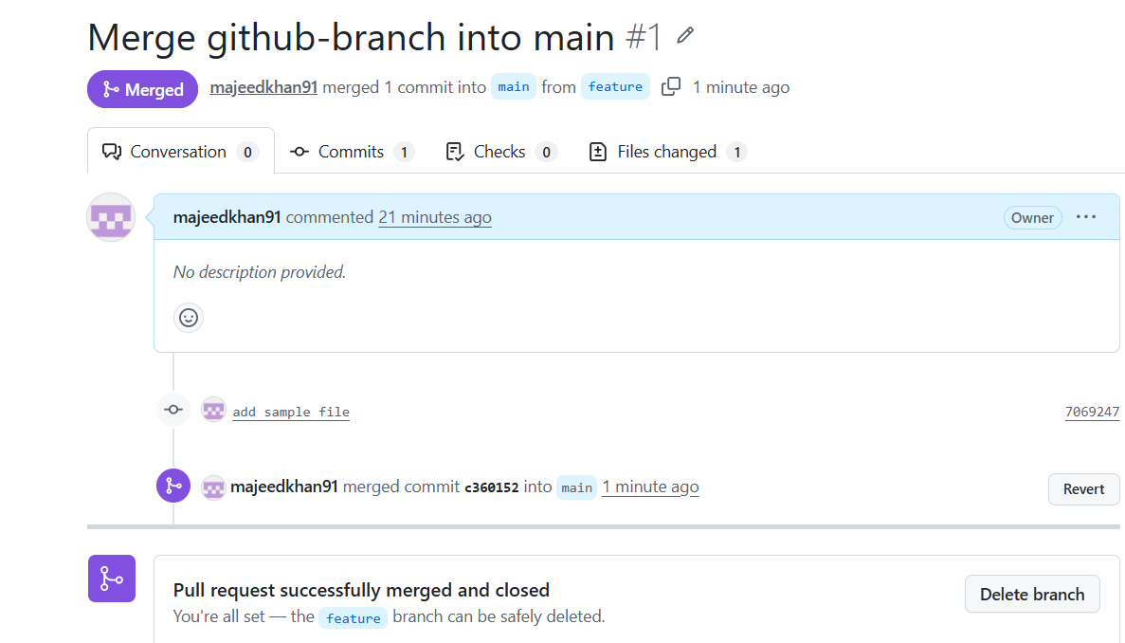
10: Create a file in local and send that to branch in github:

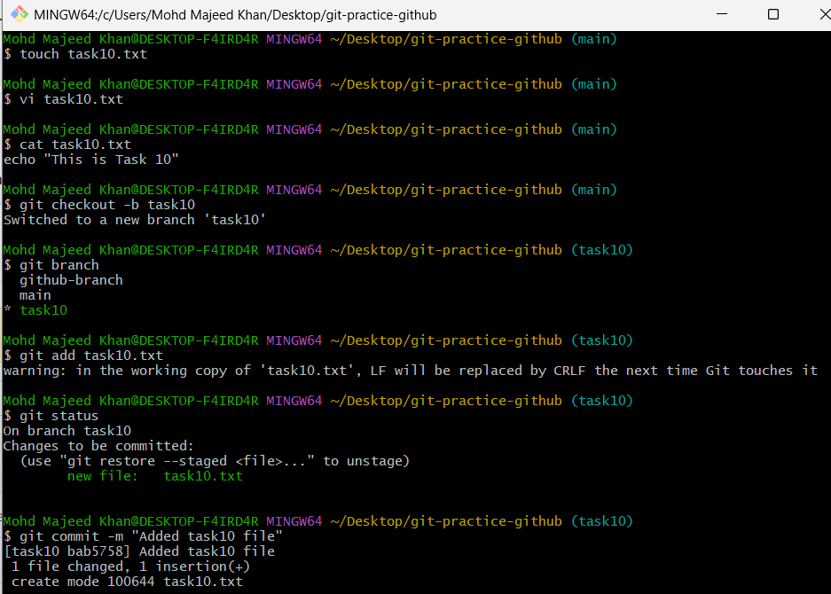
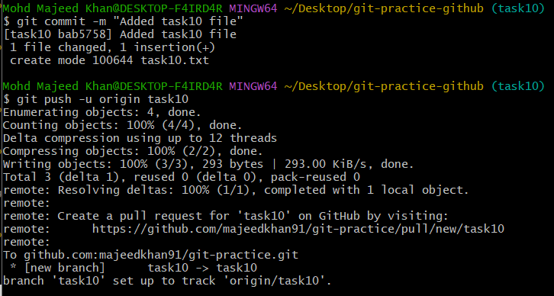
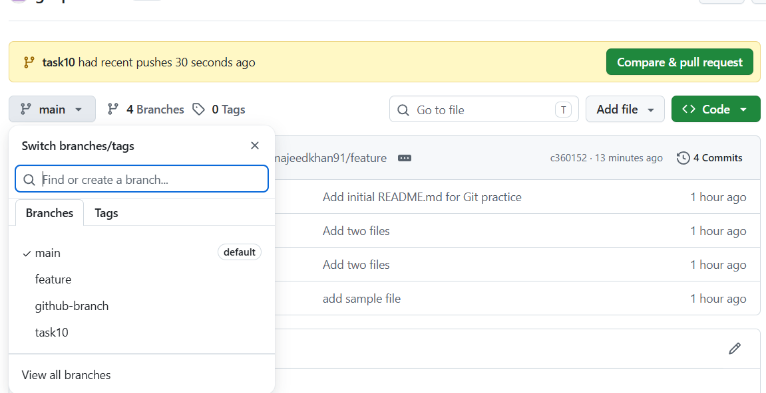

11: Clone only a branch from github to local:
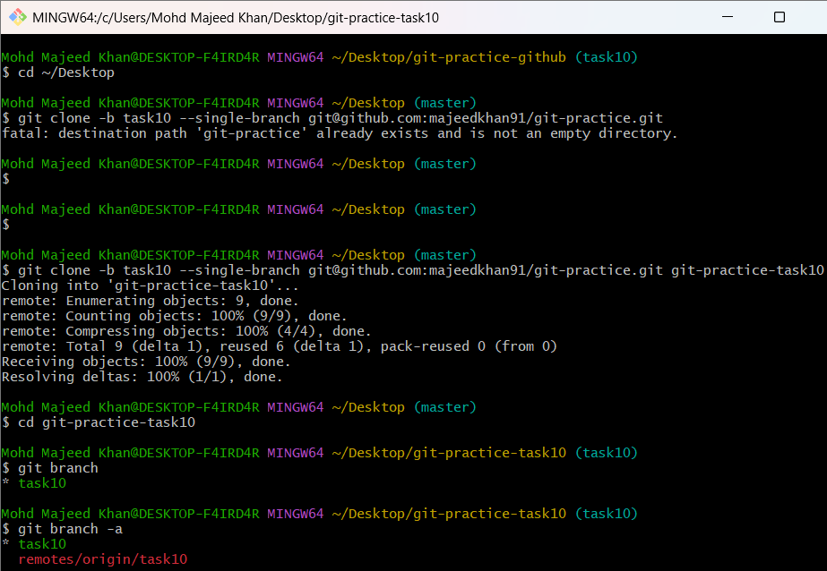

12: Create a file with all passwords and make that untrackable with git.
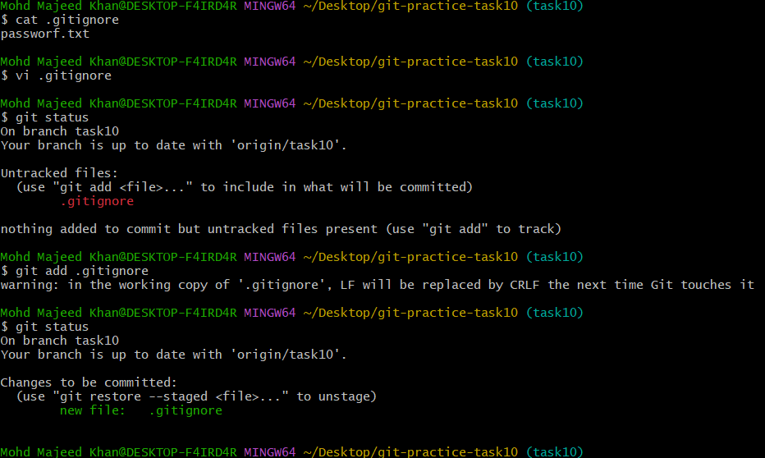

13: Make a commit and make that commit reset without savings changes.
vi task13.txt - cat task13.txt -git add task13.txt---git status----git commit -m "Add task13 file"-------git log --oneline -2
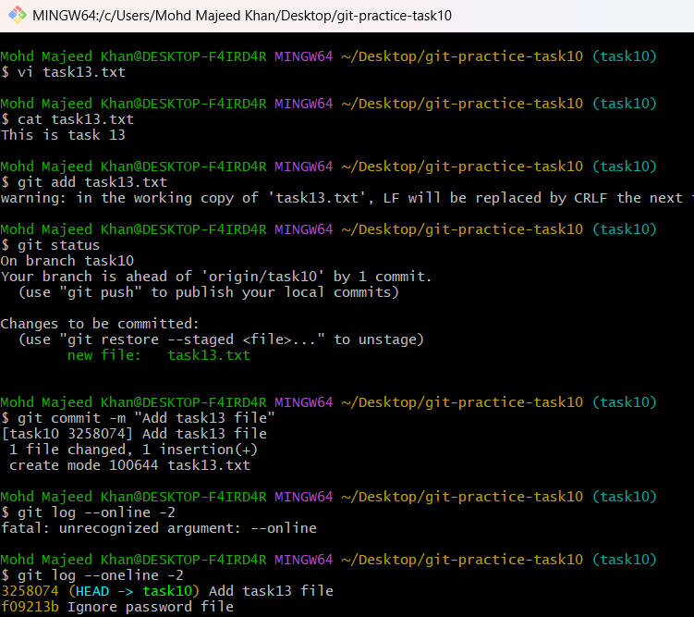
Now Step 4 — Reset the commit WITHOUT saving the changes:
git reset --hard HEAD~1 -----git status ---- git log --oneline -2
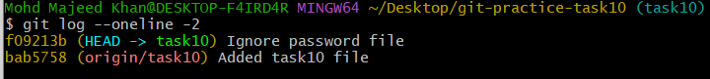

14: Revert a commited commit to the older version:

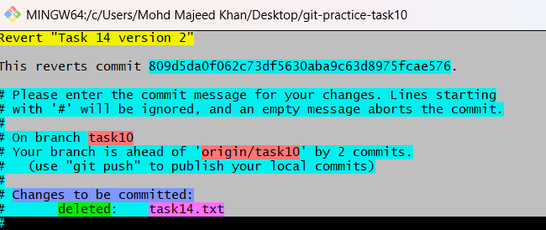
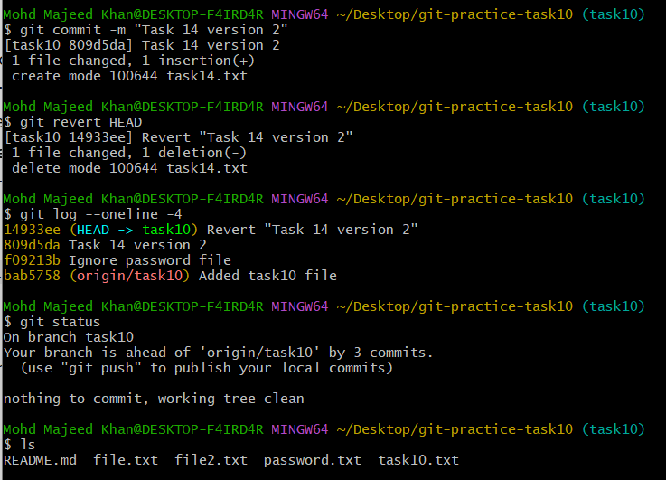

15: Push a file to stash without savings the changes and work on another file.
Step 1 — Create/change File A
echo "Task 15 changes" >> file.txt ---git status--- You should see:
modified: file.txt
- Step 2 — Stash the change
git stash----git status----git stash list---
output confirms:
stash@{0}: WIP on task10: 14933ee Revert "Task 14 version 2"
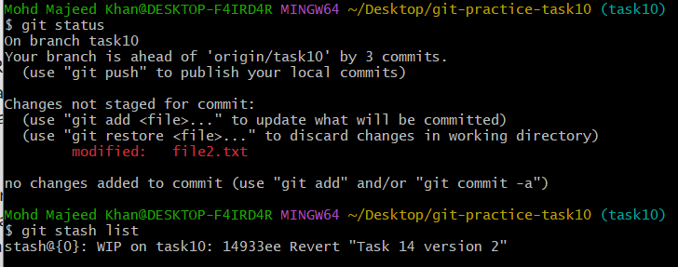

16: Undo the stash file and start working on that again.
git stash pop ---- git status----git stash list--git stash pop
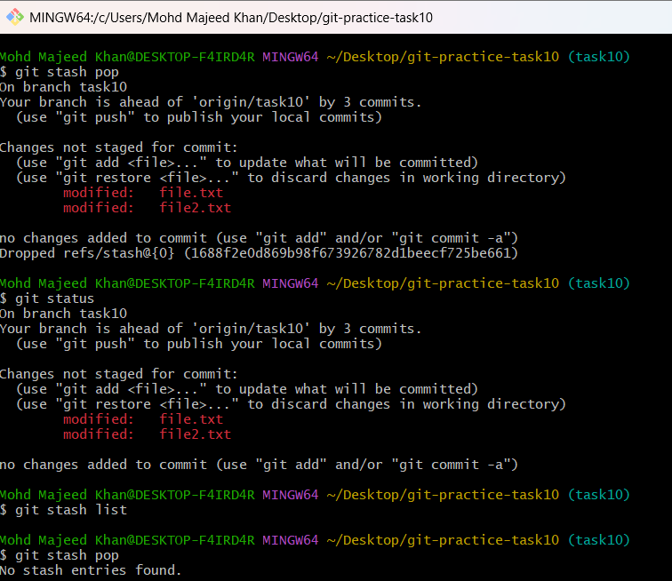

17: Generate a ssh-keygen and configure into github.
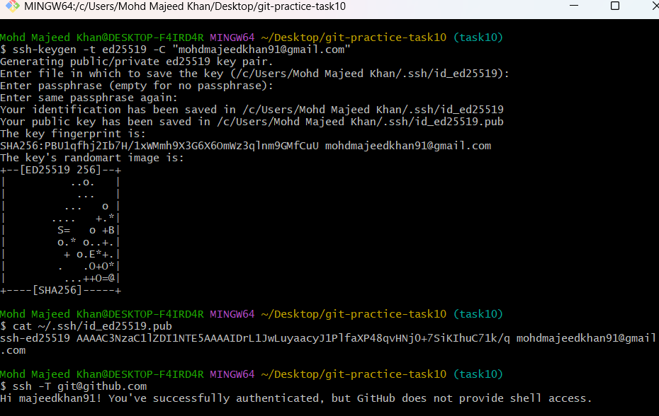

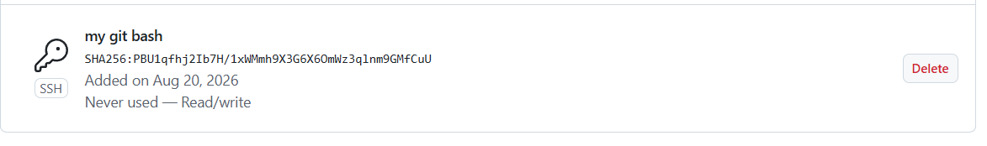

18: Configure webhooks to github
GitHub Webhook Configuration — Steps
- Open the GitHub repository.
- Go to Settings.
- Select Webhooks.
- Click Add webhook.
- In Payload URL, enter the webhook URL from Webhook.site.
- Select Content type as application/json.
- Select Just the push event.
- Make sure Active is checked.
- Click Add webhook.
- Make a push to the GitHub repository to trigger the webhook.
- Open Webhook.site and verify that the push request was received.
- In GitHub → Settings → Webhooks, check the delivery status.
- Last delivery was successful means the webhook is working successfully. ✅

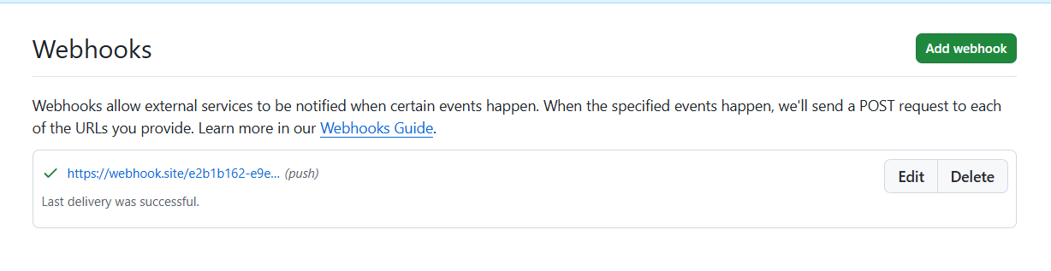
19: Basic Understanding of .git File
- .git is a hidden directory created when we run git init in a project.
- It contains all the Git information and history of the repository.
- It stores information about commits, branches, configuration, and Git objects.
- We should not manually modify or delete the .git directory unless we know what we are doing.
- If we delete .git, the project files remain, but the Git repository information is removed.

20: Check all the logs of git.
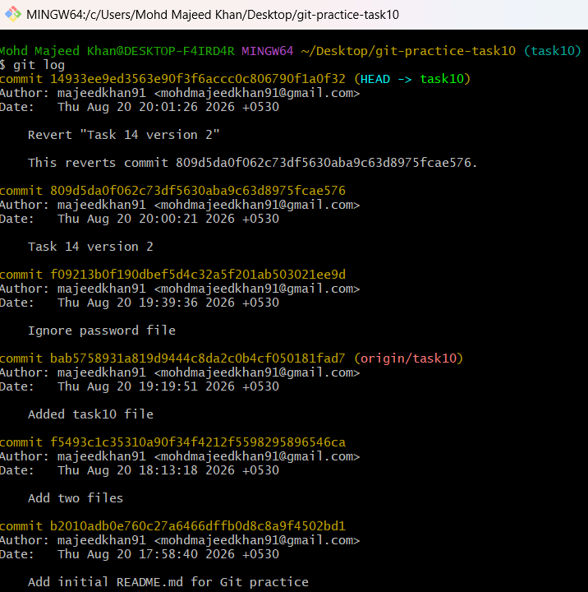

21: Rename the commit message.
git commit --amend -m "New commit message"-----git commit --amend -m "Task 14 completed"
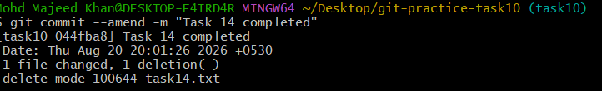
22: Merge multiple commits into single commit.
Step 1: Start interactive rebase
git rebase -i HEAD~3
Change this:
pick f09213b Ignore password file
pick 809d5da Task 14 version 2
pick 535619d Task 14 completed
To this:
pick f09213b Ignore password file
squash 809d5da Task 14 version 2
squash 535619d Task 14 completed
Task 14 completed (top first line)
